Dr. Christopher Ridley
Missionary to Africa

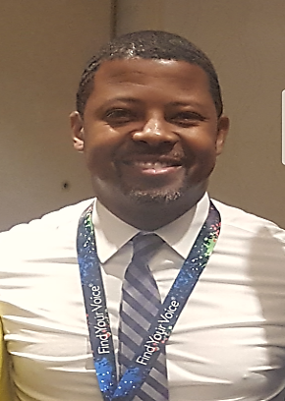
Dr. Christopher Ridley is a passionate educator that has served in the field of education as a teacher and leader for over 20 years in the Metro Atlanta and Central Georgia areas. He is currently assistant superintendent of a school system in Central Georgia. He has served as principal of both elementary and secondary schools where he has worked to increase student achievement and promote a positive school climate for Pre-K thru 8th grade students.
Dr. Ridley believes that education is his ministry and plans to work with other leaders to improve early literacy throughout the world. He is passionate about the work he and his team have done to help students reach their full potential. Literacy is a major problem in America and other countries. His prayer is to help eradicate illiteracy across the globe by making sure children have an opportunity to attend schools that focus on increasing reading and writing skills.
Dr. Ridley has donated his time, expertise and finances through the Chris Ridley Kids Foundation to help remove outside barriers that prevent students from learning. He developed a tutoring company several years ago called Show Me How Tutorial Service to help increase student achievement in all core subject areas. He currently operates an online private school for scholars in grades PK-8th grades called Ridley’s Leadership Academy, LLC.
Although Dr. Ridley spends countless hours working with children of all ages, his main focus is on his two princesses Kerrigan and Karrisan. They are his pride and joy and help to keep him motivated to do God’s work for children through education. His wife, Mia, is an educator as well and is currently working as a teacher in the Metro Atlanta area and provides online education to children in other countries.
Dr. Ridley’s greatest desire is to implement God’s plan for his life by working with students of all ages to improve literacy throughout the world. He is honored to work with Ujumbe wa Upendo Ministries as a board member and educational consultant to improve literacy in various countries.

