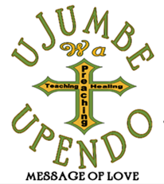
Brenda Middlebrooks
Missionary to Africa

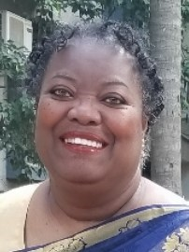
Brenda Middlebrooks is an Atlanta based pediatric nurse practitioner caring for children in many different healthcare environments from community primary care to perioperative care in a tertiary pediatric healthcare system for over thirty years.
Born in LaGrange, Georgia and reared in the Metropolitan Atlanta area, Brenda entered the Air Force after graduating high school. During this time. she received Jesus Christ as her Lord and Savior. Upon discharge from the military, she obtained her associate degree in nursing from DeKalb College (now Perimeter College), her Masters of Science in Child and Adolescent Healthcare from Georgia State University, Masters of Arts in Global Studies, Masters of Arts in Theology, and Doctor of Nursing Practice from Liberty University.
Brenda Middlebrooks believes the profession of nursing is a ministry of caring for the whole person in love and with compassion in the promotion of health, disease prevention, and intervention leading to restoring the relationship between God and His people. Access to quality healthcare is a global concern and the profession of nursing is positioned to come together globally to improve access to care. Nurses strive for the health of communities as evident by continued participation in educational opportunities, providing evidenced-based care and a commitment to spiritual development in the care of the total person. This commitment to the development of caring for the total person includes providing a stimulating environment which encourages learning and addresses the needs of students and educators of community schools.
She has participated annually over the past 18 years in providing medical services to children in Central America, South America, Eastern Europe and African communities at no cost to families. She also participates as a speaker at the annual Freedom Care Ministries International Conference in Ndejje, Uganda since 2011. She is committed to sharing the gospel of Jesus Christ and His message of love to the world.
Her family consists of her daughter Renita, son-in-law Michael and two granddaughters Aspen and Faye, who bring great joy to her life.
Brenda is indebted to God the Father who loves her, Jesus who died for her, and the Holy Spirit who empowers her. Her intention is to use the gifts granted to her by God to the fullest extent and that she leave this world empty, having given her all to His service.
Life verse: Philippians 3:10 “That I may know him, and the power of his resurrection, and the fellowship of his sufferings, being made conformable unto his death.”

